Software Downloads (follow default setup for all):
Arduino IDE: https://www.arduino.cc/en/software/
STM32CubeProgrammer: https://www.st.com/en/development-tools/stm32cubeprog.html#section-get-software-table (go to “get software”)

Software Installation
- Open Arduino IDE
- Go to File > Preferences
- In the “Additional Boards Manager URLs field” paste: https://github.com/stm32duino/BoardManagerFiles/raw/main/package_stmicroelectronics_index.json
- Click OK
- Tools > Board > Boards Manager
- Search for STM32, find the package named STM32MCU and install it (latest version
- Let it install
- Once installation is done, go to Tools > Board > STM32 MCU Based Boards
  - Select Generic STM32F1
  - In the tools menu, ensure the following settings are met
    - Board Part Number: BluiePill F103C8
    - U(S)ART Support: Enabled (generic “serial”)”
    - USB Support (if available): CDC (generic ‘Serial’ supersede U(S)ART)”
    - Upload method: STM32CubeProgrammer(SWD)
- Build with the checkmark

From Blue Pill to STLink v2
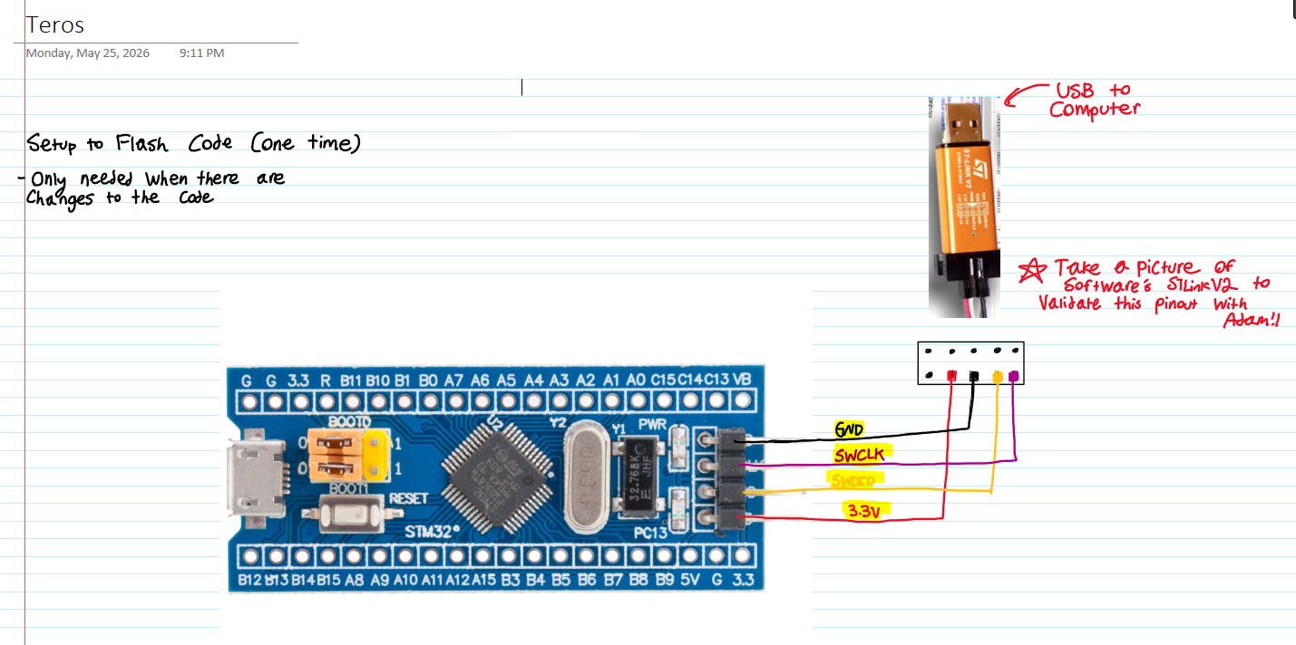
- Follow this pinout
- Click the arrow to upload

Unplug the STLink from the computer once this is done

Teros Testbench
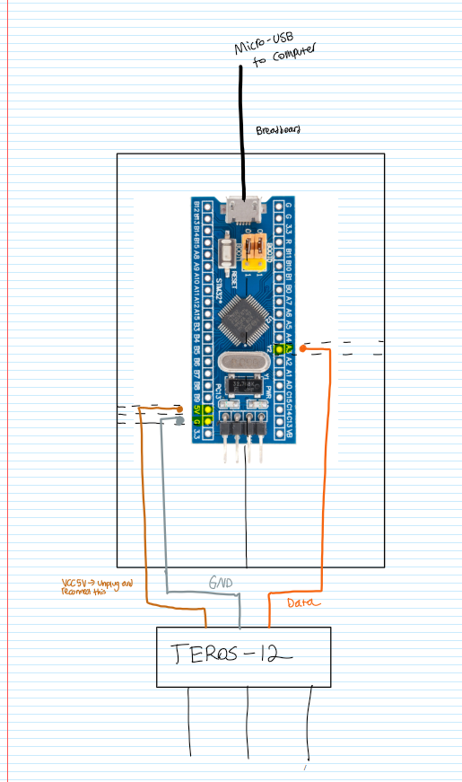

Pay close attention to the wiring in the picture to get this hooked up. Use a micro-USB cable to connect the blue pill to a computer
The blue pill will be on a breadboard

As soon as the code is flashed with the arrow the program will launch. To view output…

- Tools > Serial Monitor
- Change the Baud Rate to 115200

To get data, unplug the TEROS from the VCC 5V only and plug it back in. Do this each time you want to generate a new data point (no faster than once every 0.5 seconds)

